**“Shree Ganeshay Namah”**

**Questions:-**

1. **What is Datawarehouse/DW/DWH/EDW?**
2. **What is Datawarehousing?**
3. **Architecture of Data Ware Housing?**
4. **What are the Data Warehouse Design Approaches?**
5. **What is Data Mart?**
6. **Types of Datamats?**
7. **Difference between Dataware House and Data Mart?**
8. **What is Staging Area?**
9. **What is ODS**?
10. **What is OLTP and OLAP?**
11. **Differences between OLTP and OLAP?**
12. **What is Schema?**
13. **Types of Schema?**
14. **Difference between Start schema and Snow-flake schema?**
15. **What is Dimensional Model in Data Warehouse?**
16. **What is Dimension Table?**
17. **Types of Dimension Table?**
18. **What is SCD?**
19. **Types of SCD?**
20. **Types of SCD Type 2?**
21. **Difference between SCD Type 1, SCD Type 2 and SCD Type 3?**
22. **What is Surrogate key? What is the use of surrogate key in SCD Type 2?**
23. **Difference between SCD Type 2 and SCD Type 3?**
24. **Difference between Primary Key and Surrogate key?**
25. **What is Fact table?**
26. **Types of Fact tables?**
27. **Where Factless Fact Table is used?**
28. **Difference between Fact Table and Factless Fact Table?**
29. **Difference between Dimension Table and Fact Table?**
30. **How many Schemas are present in Datamart?**
31. **How many Fact tables are present in Datamart?**
32. What is Meta Data?
33. **Difference between Staging Area and ODS?**
34. **Difference between ODS and DWH?**
35. Types of Data warehouses?
36. Types of Data Mart?
37. Types of OLAP Servers?
38. Types of OLAP Operations?

**Answers:-**

1. **What is Datawarehouse/DW/DWH/EDW?**A data warehouse is designed to support business decisions by allowing data consolidation, analysis and reporting at different aggregate levels.

Data warehousing is a technology that aggregates structured data from one or more sources so that it can be compared and analyzed for greater business intelligence.

Data is populated into the DW through the processes of extraction, transformation and loading.

A data warehouse (DW) is a collection of corporate information and data derived from operational systems and external data sources.  
The Datawarehouse benefits users to understand and enhance their organization's performance. The need to warehouse data evolved as computer systems became more complex and needed to handle increasing amounts of Information.

**How Datawarehouse works?**

A Data Warehouse works as a central repository where information arrives from one or more data sources. Data flows into a data warehouse from the transactional system and other relational databases.

Data warehouse is used in Airline, Banking,Healthcare,Public sector,Investment and Insurance sector,Telecommunication,Hospitality Industry.

**Advantages of Data Warehouse:-**

* Data warehouse allows business users to quickly access critical data from some sources all in one place.

* Data warehouse provides consistent information on various cross-functional activities. It is also supporting ad-hoc reporting and query.

* Data Warehouse helps to integrate many sources of data to reduce stress on the production system.

* Data warehouse helps to reduce total turnaround time for analysis and reporting.

* Restructuring and Integration make it easier for the user to use for reporting and analysis.

* Data warehouse allows users to access critical data from the number of sources in a single place. Therefore, it saves user's time of retrieving data from multiple sources.

* Data warehouse stores a large amount of historical data. This helps users to analyze different time periods and trends to make future predictions.

1. **What is Datawarehousing?**  
   Datawarehousing implements the process to access data from heterogeneous or homogeneous source, clean, filter, transform and then store in structure manner in the datawarehouse that is easy to access, understand and use.
2. **Architecture of Data Ware Housing?**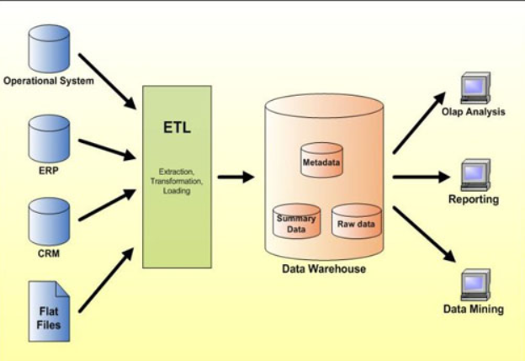
3. **What are the Data Warehouse Design Approaches?   
   Top-Down approach:-** The data warehouse is designed first and then data mart are built on top of data warehouse.

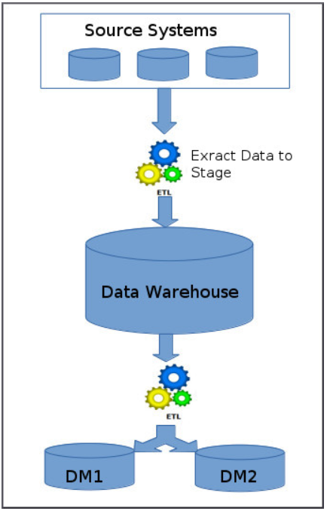

**Bottom-Up approach:-** Data marts are first created to provide the reporting and analytics capability for specific business process, later with these data marts enterprise data warehouse is created.

Also it is called dimensional modelling or the Kimball methodology.

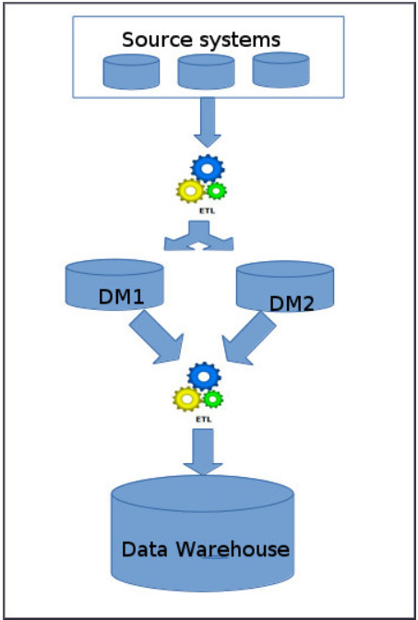

1. **What is Data Mart?**Data mart can be defined as the subset of data warehouse of an organization which is limited to a specific business unit or group of users. It is a subject-oriented database. It is oriented to a specific business line or department.

Ex.:- We can create one datamart for sale department which consists of only sale information for decisions.

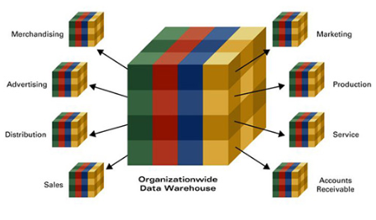

1. **Types of Datamats?**

Data marts are of two types – Dependent and Independent.

**Dependent Data Mart:–** This data mart depends on the enterprise data warehouse and works in top-down manner.

**Independent Data Mart:–** This data mart does not depend on the enterprise data warehouse and works in bottom-up manner.

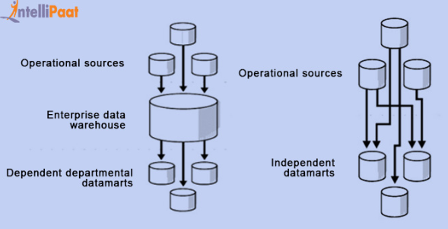

1. **Difference between Dataware House and Data Mart?**1) Datawarehouse holds multiple subject areas but Datamart holds Specific subject area for example, Finance, or Sales.

2) Data warehouse is application independent. Data mart are specific to decision support system application.

3) Holds very detailed information but May hold more summarised data (although many hold full detail).

1. **What is Staging Area?**A staging area is an intermediate storage area used for data processing during the extract, transform and load (ETL) process. The data staging area sits between the data sources and the data targets, which are often data warehouses, data marts, or other data repositories.  
   Staging area gives an opportunity to validate extracted data before it moves into the Data warehouse.
2. **What is ODS?**An operational data store (ODS) is a type of database that's often used as an interim logical area for a data warehouse.

While in the ODS, data can be scrubbed, resolved for redundancy and checked for compliance with the corresponding business rules.

An ODS can be used for integrating disparate data from multiple sources so that business operations, analysis and reporting can be carried out while business operations are occurring. This is the place where most of the data used in current operation is housed before it's transferred to the data warehouse for longer term storage or archiving.  
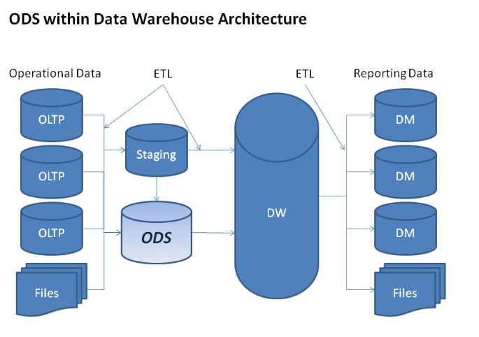

1. **What is OLTP and OLAP?**

**OLTP(Online transaction processing):-** OLTP supports transaction-oriented applications in a 3-tier architecture. OLTP administers day to day transaction of an organization.

The primary objective is **data processing and not data analysis.**

OLTP is characterized by a large number of short on-line transactions (INSERT, UPDATE, DELETE). The main emphasis for OLTP systems is put on very fast query processing, maintaining data integrity in multi-access environments and an effectiveness measured by number of transactions per second. In OLTP database there is detailed and current data, and schema used to store transactional databases is the entity model (usually 3NF).

**OLAP(Online Analytical Processing):-** A category of software tools which provide analysis of data for business decisions. OLAP systems allow users to analyze database information from multiple database systems at one time.

The primary objective is **data analysis and not data processing.**

OLAP is characterized by relatively low volume of transactions. Queries are often very complex and involve aggregations. For OLAP systems a response time is an effectiveness measure. OLAP applications are widely used by Data Mining techniques. In OLAP database there is aggregated, historical data, stored in multi-dimensional schemas (usually star schema).

1. **Differences between OLTP and OLAP?**1) OLTP is an online transactional system. It manages database modification. OLAP is an online analysis and data retrieving process.

2) OLTP used to control and run fundamental business tasks. OLAP used to help with planning, problem solving, and decision support.

3) Tables in OLTP database are normalized. Tables in OLAP database are not normalized.

4) OLTP is used by Data critical users like clerk, DBA & Data Base professionals. OLAP is used by Data knowledge users like workers, managers, and CEO.

5) OLTP queries are Insert, Update, and Delete information from the database. Mostly select operations performed on OLAP.

1. **What is Schema?**Schema is a logical description of the entire database. It includes the name and description of records of all record types including all associated data-items and aggregates.

Much like a database, a data warehouse also requires to maintain a schema.

A database uses relational model, while a data warehouse uses Star, Snowflake, and Fact Constellation schema.

1. **Types of Schema?**4(Star, Snow Flake, Galaxy, Fact Constellation)

**Star Schema:-** A star schema is the one in which a central fact table is sourrounded by denormalized dimensional tables. A star schema can be simple or complex. A simple star schema consists of one fact table where as a complex star schema have more than one fact table.

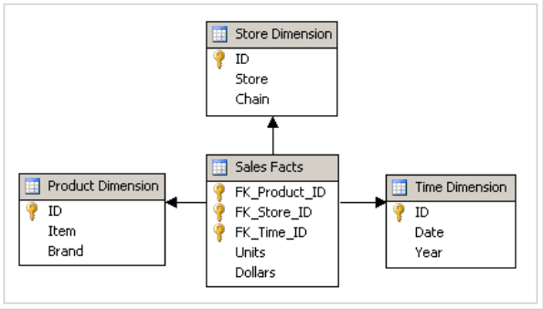

**Snow Flake Schema:-** A snow flake schema is an enhancement of star schema by adding additional dimensions. Snow flake schema are useful when there are low cardinality attributes in the dimensions.

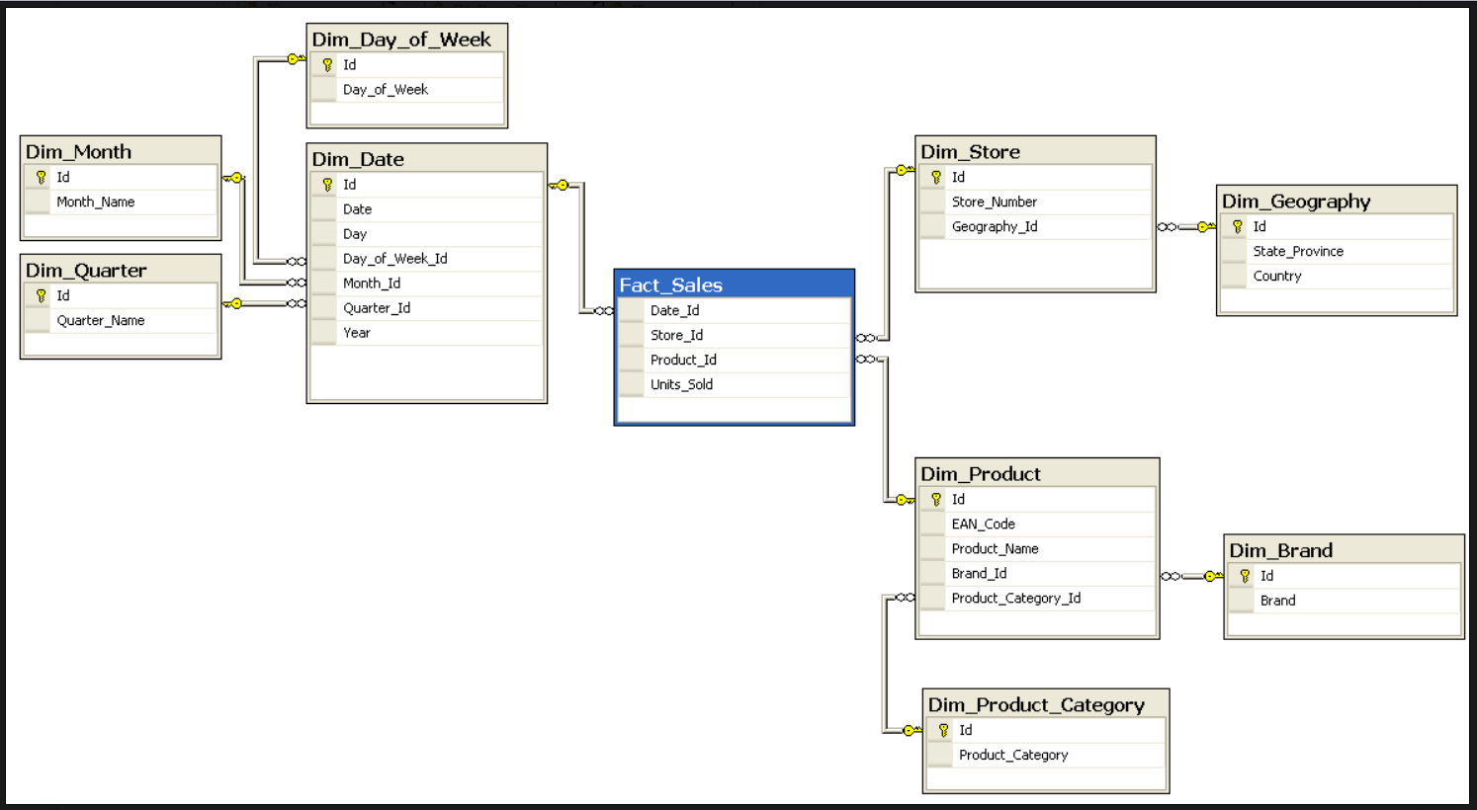

**Fact Constellation Schema:-** The dimensions in this schema are segregated into independent dimensions based on the levels of hierarchy. For example, if geography has five levels of hierarchy like teritary, region, country, state and city; constellation schema would have five dimensions instead of one.

**Galaxy Schema:-** Galaxy schema contains many fact tables with some common dimensions (conformed dimensions). This schema is a combination of many data marts.

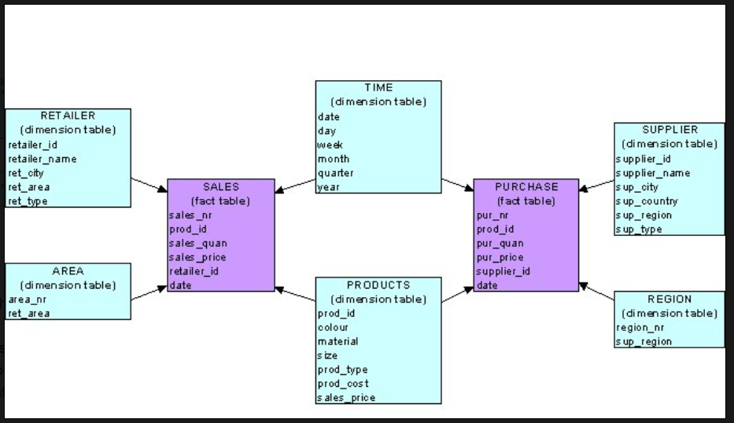

1. **Difference between Start schema and Snow-flake schema?**1) In star schema, both Dimension and Fact Tables are in De-Normalized form but in snowflake schema, Dimension Tables are in Normalized form but Fact Table is in De-Normalized form.

2) Star has Top-down approach but Snow Flake Schema has bottom-up approach.

3) A star schema contains only single dimension table for each dimension. A snowflake schema may have more than one dimension table for each dimension.

4) Star Schema has fewer joins and Snow flake has higher.

5) In star schema, Less number of foreign keys and hence shorter query execution time (faster). in snowflake schema, More foreign keys and hence longer query execution time (slower).

6) Has redundant data and hence less Star Schemas are easy to maintain/change

No redundancy, so snowflake schemas are easier to maintain and change.

7) Performance wise, star schema is good.

8) Memory wise, snow flake schema is better than star schema.

1. **What is Dimensional Model in Data Warehouse?**A dimensional model is a data structure technique optimized for Data warehousing tools. The concept of Dimensional Modelling was developed by Ralph Kimball and is comprised of "fact" and "dimension" tables.

A Dimensional model is designed to read, summarize, analyze numeric information like values, balances, counts, weights, etc. in a data warehouse. In contrast, relation models are optimized for addition, updating and deletion of data in a real-time Online Transaction System.

These dimensional and relational models have their unique way of data storage that has specific advantages.

For instance, in the relational mode, normalization and ER models reduce redundancy in data. On the contrary, dimensional model arranges data in such a way that it is easier to retrieve information and generate reports.

Hence, Dimensional models are used in data warehouse systems and not a good fit for relational systems.

Elements of Dimensional Data Model:-

1) Fact:- Facts are the measurements/metrics or facts from your business process. For a Sales business process, a measurement would be quarterly sales number

2) Dimension:- Dimension provides the context surrounding a business process event. In simple terms, they give who, what, where of a fact. In the Sales business process, for the fact quarterly sales number, dimensions would be

Who – Customer Names

Where – Location

What – Product Name

In other words, a dimension is a window to view information in the facts.

3) Attributes:- The Attributes are the various characteristics of the dimension.

In the Location dimension, the attributes can be-State,Country,Zipcode etc.

Attributes are used to search, filter, or classify facts. Dimension Tables contain Attributes

Fact Table:- A fact table is a primary table in a dimensional model.

A Fact Table contains-

i) Measurements/facts

ii) Foreign key to dimension table

Dimension table:- A dimension table contains dimensions of a fact.

They are joined to fact table via a foreign key.

Dimension tables are de-normalized tables.

The Dimension Attributes are the various columns in a dimension table.

Dimensions offers descriptive characteristics of the facts with the help of their attributes.

No set limit set for given for number of dimensions.

The dimension can also contain one or more hierarchical relationships.  
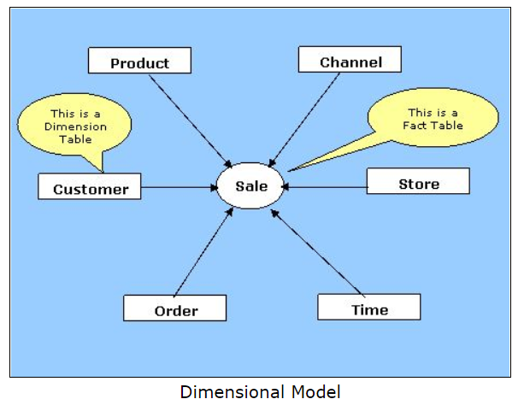

1. **What is Dimension Table?**A Dimension Table is a table in a star schema of a data warehouse. Data warehouses are built using dimensional data models which consist of fact and dimension tables. Dimension tables are used to **describe** dimensions; they contain dimension keys, values and attributes.  
   Dimension table contains descriptive data.

For example, the time dimension would contain every hour, day, week, month, quarter and year that has occurred since you started your business operations.

Product dimension could contain a name and description of products you sell, their unit price, colour, weight and other attributes as applicable. Attributes would be a customer’s first and last name, age, gender etc.

1. **Types of Dimension Table?**9(Slowly Changing, Rapidly Changing, Conformed, Degenerate, Junk, Inferred, Role Playing, Static, Shrunken)  
   **1. SCD: -** Attributes of a dimension that would changes slowly over time. This is called a slowly changing attribute and a dimension containing such an attribute is called a slowly changing dimension.  
   A Slowly Changing Dimension (SCD) is a dimension that stores and manages both current and historical data over time in a data warehouse. It is considered and implemented as one of the most critical ETL tasks in tracking the history of dimension records.

There are 3 types of SCD:- SCD Type 1, SCD Type 2, SCD Type 3.  
**2. RPD:-** A dimension is a fast changing or rapidly changing dimension if one or more of its attributes in the table changes very fast and in many rows.  
**3. Conformed Dimensions:-** A dimension that is used in multiple locations is called a conformed dimension. A conformed dimension may be used with multiple fact tables in a single database, or across multiple data marts or data warehouses.

**4. Degenerate Dimensions:-** A dimension which is stored in a fact table and has no associated dimension table is called a degenerate dimension.

A degenerate dimension is when the dimension attribute is stored as part of the fact table and not in a separate dimension table. Product id comes from product dimension table. Invoice number is a standalone attribute and has no other attributes associated with it. An invoice number can be crucial since the business would want to know the quantity of the products.

We can find number of quantity of product sold for each invoice number.  
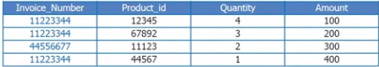

**5. Junk Dimensions:-** Junk dimensions are used to reduce the number of dimensions in the dimensional model and reduce the number of columns in the fact table. A junk dimension combines two or more related low cardinality flags into a single dimension.

Example:- Car is having color (red, black, blue, etc.) and body style (sedan, van, SUV, etc.) As you can see these are limited in number and, if created as single dimensions, the dimensions would be limited to a single attribute.

|  |  |  |  |
| --- | --- | --- | --- |
| FACT_CAR | | | |
| CAR_ID | CAR_NAME | COLOR | BODY_TYPE |
| 1 | DUSTOR | BLACK | SEDAN |
| 2 | BMW | WHITE | SEDAN |
| 3 | SKODA | BLACK | SUV |

In order to eliminate these small dimensions, we create a single “junk” dimension which cross joins all possible attributes into a single dimension which will be used in the fact table.

|  |  |  |
| --- | --- | --- |
| DIM_CAR_ATTRIBUTE | | |
| DCA_KEY | DCA_COLOR | DCA_BODY_TYPE |
| 1 | BLACK | SEDAN |
| 2 | WHITE | SEDAN |
| 3 | RED | SEDAN |
| … | … | … |
| 101 | BLACK | SUV |
| 102 | WHITE | SUV |
| 103 | RED | SUV |

|  |  |  |
| --- | --- | --- |
| FACT_CAR | | |
| CAR_ID | CAR_NAME | DCA_KEY |
| 1 | DUSTOR | 1 |
| 2 | BMW | 2 |
| 3 | SKODA | 101 |

By combining these into a single dimension we have made the model easier to understand and use by both IT and business users.

A junk dimension is a convenient grouping of typically low-cardinality flags and indicators. By creating an abstract dimension, these flags and indicators are removed from the fact table while placing them into a useful dimensional framework.  
**6. Inferred Dimensions:-** While loading fact records, a dimension record may not yet be ready. One solution is to generate a surrogate key with null for all the other attributes. This should technically be called an inferred member, but is often called an inferred dimension.  
**7. Role Playing Dimensions:-**   
A dimension table that has multiple valid relationships with a fact table.

Dimensions which are often used for multiple purposes within the same database are called role-playing dimensions.

For example, a date dimension can be used for “date of sale", as well as "date of delivery", or "date of hire".

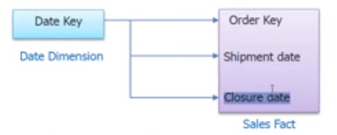

In the above example, there are multiple keys in the fact table pointing to the same dimension.

Date dimension can be used to fetch Ordered fetch date, order shipment date and order closure date.

**8. Static Dimensions:-** A static dimension is a dimension that is not loaded from the source system.

The static dimensions are generated using a SQL script or a stored procedure and are manually loaded. The time dimension is a classic example of a static dimension. Also, status codes dimension is mostly a static dimension.

**9. Shrunken Dimensions:-** A shrunken dimension is a subset of another dimension. For example, the orders fact table may include a foreign key for product, but the target fact table may include a foreign key only for product category, which is in the product table, but much less granular. Creating a smaller dimension table, with product category as its primary key, is one way of dealing with this situation of heterogeneous grain. If the product dimension is snowflaked, there is probably already a separate table for product category, which can serve as the shrunken dimension.

1. **What is SCD?**A Slowly Changing Dimension (SCD) is a dimension that stores and manages both current and historical data over time in a data warehouse. It is considered and implemented as one of the most critical ETL tasks in tracking the history of dimension records.
2. **Types of SCD?**3(SCD Type 1,SCD Type 2,SCD Type 3)  
   **Type 1 SCDs – Overwriting the old values**

In a Type 1 SCD the new data overwrites the existing data. Thus the existing data is lost as it is not stored anywhere else. This is the default type of dimension you create. You do not need to specify any additional information to create a Type 1 SCD.  
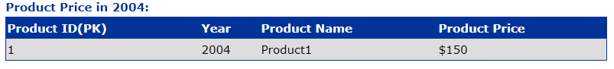

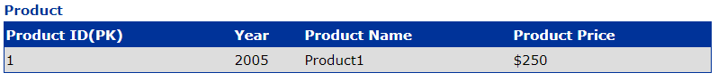

**Type 2 SCDs - Creating another additional dimension record**

A Type 2 SCD retains the full history of values. When the value of a chosen attribute changes, the current record is closed. A new record is created with the changed data values and this new record becomes the current record. Each record contains the effective time and expiration time to identify the time period between which the record was active.  
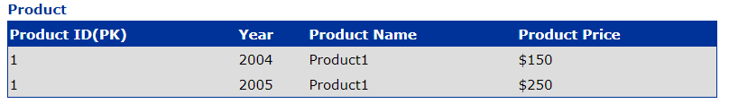

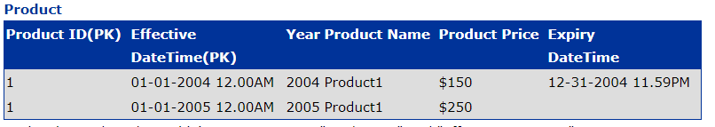

**Type 3 SCDs - Creating a current value field**

A Type 3 SCD stores two versions of values for certain selected level attributes. Each record stores the previous value and the current value of the selected attribute. When the value of any of the selected attributes changes, the current value is stored as the old value and the new value becomes the current value.  
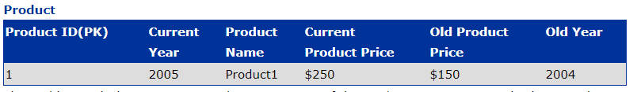

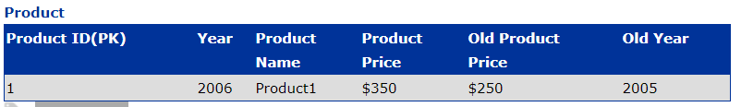

1. **Types of SCD Type 2?**SCD type 2 stores the entire history the data in the dimension table. With type 2 we can store unlimited history in the dimension table. In type 2, you can store the data in three different ways. They are-

(1) SCD Type 2 Versioning

(2) SCD Type 2 Flagging

(3) SCD Type 2 Effective Date

**(1) SCD Type 2 Versioning:**- In versioning method, a sequence number is used to represent the change. The latest sequence number always represents the current row and the previous sequence numbers represents the past data.

Ex.:- let’s use the same example of customer who changes the location. Initially the customer is in Illions location and the data in dimension table will look as.

surrogate_key customer_id customer_name Location Version

------------------------------------------------------------------------------

1 1 Marston Illions 1

The customer moves from Illions to Seattle and the version number will be incremented. The dimension table will look as

surrogate_key customer_id customer_name Location Version

-------------------------------------------------------------------------------------

1 1 Marston Illions 1

2 1 Marston Seattle 2

Now again if the customer is moved to another location, a new record will be inserted into the dimension table with the next version number.  
**(2) SCD Type 2 Flagging:** In flagging method, a flag column is created in the dimension table. The current record will have the flag value as 1 and the previous records will have the flag as 0.

Now for the first time, the customer dimension will look as.

surrogate_key customer_id customer_name Location flag

---------------------------------------------------------------------------------------

1 1 Marston Illions 1

Now when the customer moves to a new location, the old records will be updated with flag value as 0 and the latest record will have the flag value as 1.

surrogate_key customer_id customer_name Location Version

--------------------------------------------------------------------------------------

1 1 Marston Illions 0

2 1 Marston Seattle 1  
**(3) SCD Type 2 Effective Date:** In Effective Date method, the period of the change is tracked using the start_date and end_date columns in the dimension table.

surrogate_key customer_id customer_name Location Start_date End_date

-----------------------------------------------------------------------------------------------------

1 1 Marston Illions 01-Mar-2010 20-Fdb-2011

2 1 Marston Seattle 21-Feb-2011 NULL

The NULL in the End_Date indicates the current version of the data and the remaining records indicate the past data.

1. **Difference between SCD Type 1, SCD Type 2 and SCD Type 3?**Type 1 SCDs - Overwriting the old values.

Type 2 SCDs - Creating another dimension record.

Type 3 SCDs - Creating a current value field.

1. **What is Surrogate key? What is the use of surrogate key in SCD Type 2?**Surrogate key is a unique identification key. Surrogate key is always single numeric key.  
   Surrogate keys are used as primary key in dimension table.
2. **Difference between SCD Type 2 and SCD Type 3?**

**Difference:-** SCD2 is unlimited history and SCD3 is limited history.

**Explanation:-** Using SCD2 you can save unlimited history with the help of the Surrogate Key. In this structure of the table will never be effected (constant) only the no of the rows will be effected(will be increased) and to prevent the duplication of data ,primary key will be used.

While in SCD3 you can save the limited history. There is no use of Surrogate Key. Since here it depends upon you how much old history/data you want to save (for example: till second last , third last and so on....). As much old data want to save as much no. of columns will be required to add to the table.

1. **Difference between Primary Key and Surrogate key?  
   Primary Key:-** UNIQUE and NOT NULL

A primary key is a special constraint on a column or set of columns.

A primary key constraint ensures that the column(s) so designated have no NULL values, and that every value is unique.

Physically, a primary key is implemented by the database system using a unique index, and all the columns in the primary key must have been declared NOT NULL. A table may have only one primary key, but it may be composite (consist of more than one column).

**Surrogate Key:-** A surrogate key is any column or set of columns that can be declared as the primary key instead of a "real" or natural key. Sometimes there can be several natural keys that could be declared as the primary key, and these are all called candidate keys. So a surrogate is a candidate key. A table could actually have more than one surrogate key, although this would be unusual. The most common type of surrogate key is an incrementing integer, such as an auto_increment column in MySQL, or a sequence in Oracle, or an identity column in SQL Server.

1. **What is Fact table?**

A fact table is the one which consists of the measurements, metrics or facts of business process.

1. **Types of Fact tables?**

**Additive:-** Additive facts are facts that can be summed up through all of the dimensions in the fact table.

Ex:- A sales fact is a good example for additive fact. We can aggregate all columns.

**Semi-Additive:-** Semi-additive facts are facts that can be summed up for some of the dimensions in the fact table, but not the others.

Eg: Daily balances fact can be summed up through the customers dimension but not through the time dimension.

We can aggregate some columns.

**Non-Additive:-** Non-additive facts are facts that cannot be summed up for any of the dimensions present in the fact table.

Eg: Facts which have percentages 40%, ratios 1:4 calculated.

We cannot aggregate columns.

**Factless Fact Table:-** In the real world, it is possible to have a fact table that contains no measures or facts. These tables are called "Factless Fact tables".

Eg: A fact table which has only product key and date key is a factless fact. There are no measures in this table. But still you can get the number products sold over a period of time. We cannot aggregate columns.

1. **Where Factless Fact Table is used?**We know that fact table is a collection of many facts and measures having multiple keys joined with one or more dimesion tables. Facts contain both numeric and additive fields. But factless fact table are different from all these.

**A factless fact table is fact table that does not contain fact.** They contain only dimesional keys and it captures events that happen only at information level but not included in the calculations level. Just an information about an event that happen over a period.

A factless fact table captures the many-to-many relationships between dimensions, but contains no numeric or textual facts. They are often used to record events or coverage information.

**Common examples of factless fact tables include:-**

* Identifying product promotion events (to determine promoted products that didn’t sell)

* Tracking student attendance or registration events

* Tracking insurance-related accident events

* Identifying building, facility, and equipment schedules for a hospital or university

Factless fact tables are used for tracking a process or collecting stats. They are called so because, the fact table does not have aggregatable numeric values or information. There are two types of factless fact tables: those that describe events, and those that describe conditions. Both may play important roles in your dimensional models.

1. **Difference between Fact Table and Factless Fact Table?**A fact table is the one which consists of the measurements.

Factless table means only the keys are available in the Fact while there are no measures available.

1. **Difference between Dimension Table and Fact Table?**1) Dimension Table contains descriptive attributes. Fact table contains Measurements.

2) Dimension tables are de-normalized tables but fact tables are normalized tables.

3) Dimension tables are Connected to the fact table and located at the edges of the star or snowflake schema.

Fact tables are Located at the center of a star or snowflake schema and surrounded by dimensions.

4) Dimension table fields is Foreign key to the facts table.

Primary Key in fact is mapped as foreign keys to Dimensions.

1. **How many Schemas are present in Datamart?**There are multiple schemas are present in 1 datamart. Means we can create multiple star and snowflake schemas in 1 datamart.
2. **How many Fact tables are present in Datamart?**We can create multiple fact tables in 1 datamart.
3. **What is Meta Data?**
4. **Difference between Staging Area and ODS?  
   Staging Area :-** It is temp work area. It comes after the etl has finished.

Staging Area consists of

1. Meta Data .

2. The work area where we apply our complex business rules.

3. Hold the data and do calculations.  
**ODS :-** Operational Data Store which contains data. ODS comes after the staging area. ODS information would contain cleansed data only ie after staging area.

Ex:- In our e.g lets consider that we have day level Granularity in the OLTP & Year level Granularity in the Data warehouse.

If the business(manager) asks for week level Granularity then we have to go to the OLTP and summarize the day level to the week level which would be pain taking.So wat we do is that we maintain week level Granularity in the ods for the data,for abt 30 to 90 days.

1. **Difference between ODS and DWH?**  
   1) ODS database designed for queries on transactional data. An ODS is often an interim or staging area for a data warehouse, but differs in that its contents are updated in the course of business, whereas a data warehouse contains static data.

2) An ODS is designed for performance and numerous queries on small amounts of data such as an account balance. A data warehouse is generally designed for elaborate queries on large amounts of data.

1. **Types of Data warehouses?**

Three main types of Data Warehouses are:-

**1. Enterprise Data Warehouse:-** Enterprise Data Warehouse is a centralized warehouse. It provides decision support service across the enterprise. It offers a unified approach for organizing and representing data. It also provide the ability to classify data according to the subject and give access according to those divisions.

**2. Operational Data Store:-** Operational Data Store, which is also called ODS, are nothing but data store required when neither Data warehouse nor OLTP systems support organizations reporting needs. In ODS, Data warehouse is refreshed in real time. Hence, it is widely preferred for routine activities like storing records of the Employees.

**3. Data Mart:-** A data mart is a subset of the data warehouse. It specially designed for a particular line of business, such as sales, finance, sales or finance. In an independent data mart, data can collect directly from sources.

1. **Types of Data Mart?**???
2. **Types of OLAP Servers?**ROLAP(Relational OLAP),MOLAP(Multidimensional OLAP),HOLAP(Hybrid OLAP),Specialized SQL Servers
3. **Types of OLAP Operations?**Roll-up, Drill-down, Slice, Dice, Pivot(rotate)